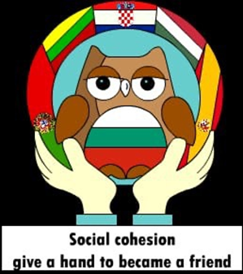

WITHOUT BULLYING
Erasmus + project ‘‘Social cohesion give a hand to become a friend“
2019-1-BG01-KA229-062313_4

The goal of the project
-To initiate educational activities and create material aimed at school staff, students and parents.
-To raise the awareness of the society towards bullying (social campaigns, etc.)
-To change the favorable attitude and myths of the society towards bullying and form an unfavorable attitude.

Dear Sir / Madam, by completing this questionnaire, you are helping us to research happiness, which is part of the Erasmus + project
” Social cohesion - give a hand to become a friend” 2019-1-BG01-KA229-062313_4
Please answer all questions so that the results are as complete as possible. The examination is completely anonymous. Thank you for your hard work in this research!

Please choose one answer to each question.
- Gender:

1. Male
2. Female
3. Other
2.
I am a year old

Questions | No | Sometimes | Regulary
1.Been glared at in a hostile manner?
2. Been excluded from work or study-related social gatherings?
3. Been subjected to negative comments about your intelligence or competence?
4. Been treated in a rude or disrespectful manner?
5. Not been given the praise for which you felt entitled?
6. Had others refuse your requests for assistance?
7. Had others fail to deny false rumors about you?
8. Been given little or no feedback about your performance?
9. Had others delay action on matters that were important to you?
10. Had others storm out of the work area when you entered?
11. Had others consistently arrive late for meetings that you called?
12. Been given the “silent treatment”?
13. Been yelled at or shouted at in a hostile manner?
14. Had others consistently fail to return your telephone calls or respond to your memos or e-mail?
15. Had your contributions ignored by others?
16. Had someone interfere with your learning/ work activities?
17. Had others destroy or needlessly take resources that you needed to do your job?
18. Been accused of deliberately making an error?
19. Been subjected to mean pranks?
20. Been lied to?
21. Had others fail to give you information that you really needed?
22. Been prevented from expressing yourself (for example, interrupted when speaking)?
23. Been subjected to derogatory name calling?
24. Had attempts made to turn other students against you?
25. Been the target of rumors or gossip?
26. Had someone flaunt his or her status or treat you in a condescending manner?
27. Shown little empathy or sympathy when you were having a tough time?
28. Had someone else take credit for your ideas?
29. Does your school effective a bullying prevention program?
30. What do you think teachers, school administration help you to address bullying

