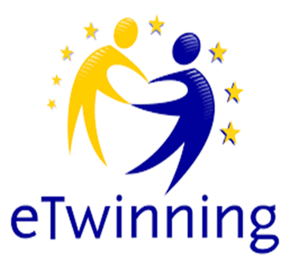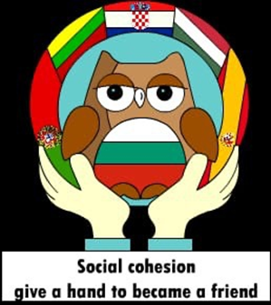

Dear Sir / Madam, by completing this questionnaire, you are helping us to research happiness, which is part of the Erasmus + project
” Social cohesion - give a hand to become a friend” 2019-1-BG01-KA229-062313_4
Please answer all questions so that the results are as complete as possible. The examination is completely anonymous. Thank you for your hard work in this research!

Please choose one answer to each question.
1. Gender:
1. Male
2. Female
3. Other
2.
I am a year old

The following set of questions relates to your views on happiness. Please circle each claim with one number that reflects your agreement with the claim, and the numbers mean the following:
1- I strongly disagree
2- I partially disagree
3 – Neither agree or disagree
4 – I partially agree
5 – I strongly agree

I am happy when I feel safe! | 1 | 2 | 3 | 4 | 5
Happiness are my friends! | 1 | 2 | 3 | 4 | 5
Happiness is a good relationship within the family! | 1 | 2 | 3 | 4 | 5
Happiness are good grades in school! | 1 | 2 | 3 | 4 | 5
Happiness is a good relationship with classmates! | 1 | 2 | 3 | 4 | 5
Happiness is participation in different projects and activities! | 1 | 2 | 3 | 4 | 5
Happiness is to have an latest mobile! | 1 | 2 | 3 | 4 | 5
Happiness is getting a driving licence. | 1 | 2 | 3 | 4 | 5
Happiness is health! | 1 | 2 | 3 | 4 | 5
Happiness is having a good time when going out! | 1 | 2 | 3 | 4 | 5
Happiness is money! | 1 | 2 | 3 | 4 | 5
I'm a happy person! | 1 | 2 | 3 | 4 | 5
I am happy with my life! | 1 | 2 | 3 | 4 | 5

