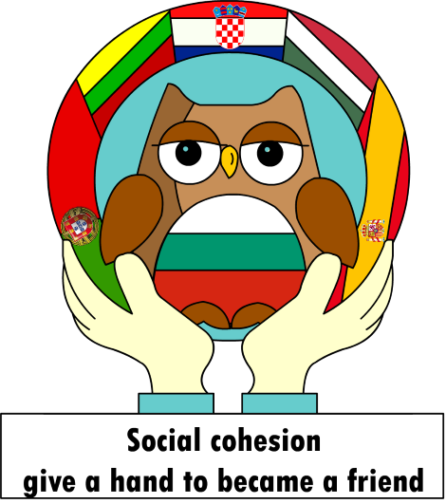

GIMNAZJA I STRUKOVNA ŠKOLA
BERNARDINA FRANKOPANA,
OGULIN, CROATIA
STRUGA 3, 47 300 OGULIN

AGENDA

OGULIN, CROATIA
14.03.2022. – 18.03.2022.

Day 1. – 13.03.2022.
– Arrival – Croatia; Zagreb – Ogulin

Day 2. – 14.03.2022.
- Hotel Frankopan – Breakfast/Host family
- 11:00 – Opening ceremony
- Hymn of the Republic of Croatia and the European Union
- Welcome speeches
- Presentation of the partners of the project participants (5 minutes per country)
- Exhibition of cultural things from home countries – School hallway – International Art Corner
- Paretnt meeting - Local food (lunch) – School hallway
- cooperation with local people and press
  - Radio Ogulin
  - Og portal
  - Ogulin.eu
- 13:00 - Cultural awareness – Sport-cultural games
  - 15:00 city tour with Sabina – Turistička zajednica Grada Ogulina
  - KUD Klek, Ogulin – 16:00
  - KUD Sv. Juraj Zagorje Ogulinsko – 16:30
  - Ogulinske mažoretkinje, Društvo naša djeca – 16.00
- Free time
- Dinner – own organization (Hotel Frankopan, Stross, Pizzeria Bonino, Pizzeria Antica…)

Day 3. – 15.03.2022.
- Hotel Frankopan – Breakfest/Host family
- Teacher meeting – list of participant, plan
- 09:00 – Hikking to a mountain Klek in natural environment with music for inceasing mental happines
- HGSS – Croatian mountain rescue service – lesson
- Lunch – sandwiches (pareents – host family) – Klek
- Hrvatsko planinarsko društvo Klek, Ogulin
- Free time
- Dinner – own organization (Hotel Frankopan, Stross, Pizzeria Bonino, Pizzeria Antica…)

Day 4. – 16.03.2022.
- Hotel Frankopan – Breakfest/Host family
- Teacher meeting – list of participant, plan
- 09:30 – Ogulin – Glagoljica u gostima – Obrtnička i tehnička škola – How to increase multilingualism?
- 10:00 – Ogulin – Market Day
- Free time
- 11:30 – School
- Language Class – School – Web dictionary
- Anti stress activities – Dont hate mediate
  - Zumba – Društvo za sportsku rekreaciju, Ogulin
- Lunch – own organization (Hotel Frankopan, Stross, Pizzeria Bonino, Pizzeria Antica…)
- 14:00 – Ogulin – City
- 14:00 Museum
- History lesson – Laboratory of ideas – Museum
  - Frankopanska garda – photos and lesson about Bernardin Frankopan
- 15:00 Fairtale haus
- Dance festival + Certificate
- Free time
- Dinner – Ogulin – Hotel Frankopan – for teachers

Day 5. – 17.03.2022.
- Hotel Frankopan – Breakfest/Host family
- Teacher meeting – list of participant, plan
- 08:30 – excursion – Plitvička jezera
- Lunch (own organization – all together) – Plitvička jezera
- ICT workshop – photos and videos – Video about hiking and autdoor activities
- Free time
- KUD “Tounjčica”, Tounj
- Dinner – own organization (Hotel Frankopan, Stross, Pizzeria Bonino, Pizzeria Antica…)

Day 6. – 18.03.2022.
- Hotel Frankopan – Breakfest/Host family
- Teacher meeting – list of participant, plan
- 08:30 – excursion – Zadar
- Workshop on democratic inclusion: How students can contribute to democratic inclusion at schools
- Free time
- City tour
- Lunch – Zadar – own organization (all together)
- Dinner – own organization (Hotel Frankopan, Stross, Pizzeria Bonino, Pizzeria Antica…)

Day 7. – 19.03.2022.
- Departure – Croatia, Ogulin, Zagreb

