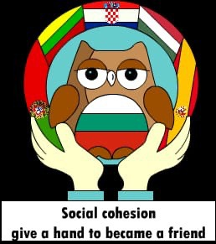
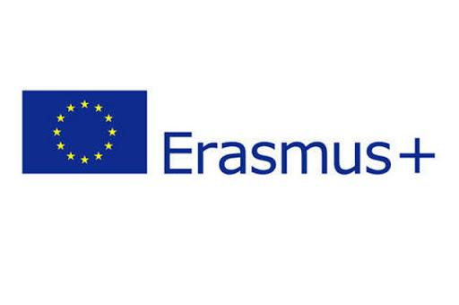

STUDENTS FEEDBACK
2019-1-BG01-KA229-062313_4

2. How would you rate the week?
a) how happy were you with your partner? With my partner I felt ......................?
Great
Comfort and fine
Very kind and safe
Fine
Very happy.
Really happy
very good around everyone
Very happy
good
they were really hospitable and kind
It was very good because he was so nice
Fine, good
excited
Really happy
Nice , fine
good because he is funny and good guy

`

\
Speaking style
İ dont know
Kindness
We are not so different after all
Very welcoming and loving people who love their traditions.
Football
they are very tasty dishes that are similar to ours
Our hobbies
some foods
House rules and respect to houshold members
Didn't see them
We both hospitable
hospitable
I don't no, I just noticed some random things
We are both hospitable
my partners family respect for traffic rules and we are respect traffic rules too
we have the same tastes
Pensamento

3. What similarity between your cultures (your own and your partner´s) did you see?

4. What difference between your cultures (your own and your partner´s) did you see?
Food and religionous thing
İ dont know
Brains
No difference
There are differences in our traditions, holidays, festivals etc. They are unique in their own way, and i loved that I can learn more about other cultures.
Food
the pancakes day
The food
hospitable
meals and foods
Didn't see
We have delight they don't have
foods
They hug and kiss each other to much
we are have different holidays like a you are have Mardi Gras holiday but we dont have or we are have Sacrificing Holiday and you dont have
anything
Comida

g) What will you remember most from this trip?
My partner and other National friends
Guys symphaty
When we first met
The people i met
The fun activities and of course the loving people.
Pink soup
About the pepople that are around that place
The friends I made
this travel
my friends
Kaunas
My partner
improve english
The pink soup and the people
My partner and my partner's family
here because its my first abroad trip
of people
Está viagem

I had a problem when ......?
I‘m scared
I didnt have a problem
I didn't have any problem.
when I didn't know how to use the shower
i didn t had any problem
I didn’t understand something
i say my partner
i was in alone in park we figured it out :)
No problems
I didn't have a problem
i don't like the food
Sometimes I could pronounce their names
I'm try solve the problem and if i cant solve im consult my teacher
No
Ele não falou muito

I found it easy to communicate because/ when........?
Everyone knew how to speak good english to a point
Because everyone knows english very well and it was very easy communicating with eachother.
because I know the basics
they are not shy people
They know english well
i wont talk my friend
everybody was so intimate
I ask him something he always tell me.
I want to say something I can say this easily
i know my words
I don't no, was just easy
I want to say something I can say easily
I m found easy almost everytime
Yes
Até que foi fácil

I found it hard to communicate because /when ....?
Not everyone was open for talking
When we couldn't think how to say some words in english and had to use translate.
because of the accent
because our lengueges are very different
His parents didn't know English very well
i dont know some words
of language differences
Not hard.
I am excited
i don't know some words
Because of the accents
I am excited
im didnt find communication difficult.
No
Ele falava muito rápido

7. What cultural differences you see between your country and your partner?
Nothing
Probably food
Everything is different
I can't write them all, there are differences between our contries, but the differences make our contries very unique and beautiful.
Temperature
i didn t
The food
they have diffrent foods
traffic rules
I don't know
I didn't see any difference
cooking types
Basically everything
In our country the traffic is worse than Litvania
i said that 4. question we are have different holidays
I don't no
Frio

9. Is there anything else you would like to share with us?
No
no
Lithuanian girls and boys have a big and soft heart and (lithuanian girls are so pretty)
No, there isn't.
no
No.
I will like to do this again
no i dont have
Não

10. Would you like to give any hints for a future Erasmus+ project? What could we improve
next time?
No
Maybe
Don't have to improve anything. Everything was SUPER.
Give more free time
i think it is perfect
free times can be more free not about the time about the things that we can do.
Maybe more going to another city's
i like it i think it is good
They shouldn't put the students doing maps is pretty boring And will be good some more time in the country
i think its okay

