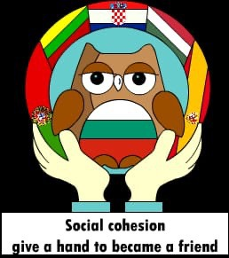
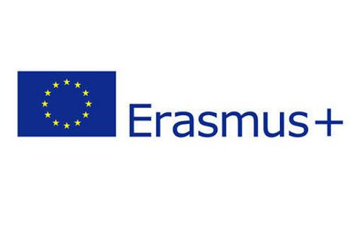

TEACHERS FEEDBACK
2019-1-BG01-KA229-062313_4

Participation in this project contributed to:

8. What was your first impression of Lithuania?
Very hardworking people and organized
A beautiful, clean, organised and very modern city.
Great people, hospitality, hard working and very clean
Silence and clean streets
Excellent,
Clean City, happy faces
Happy anda smiling faces
Clean City happpy faces
A clean country
A beautiful land.
A country with beautiful people who respect nature and with warm people.

What similarity between your cultures did you see?
The warm form to recieved the Foreigner people
Hospitality and warm behaviour
Hospitality and very caring tteachers and families
Welcoming
communicative people.
Very hospitable people like us, funny students
Welcoming is similar
Hospitality
Positive thinking
The proud in traditions and history.
The preservation of traditions, hospitality.

What difference between your cultures did you see?
All the the history have diferents culture tradicional
Lithuanians respect more public space.
Very clean and relaxing mind and atmosphere
Solidarity is better in your country
No, it's the same.
Preserve the Cultural activies better than us, have better İT atmosphere
Solidarity is perfect here
Solidarity is better than us
No traffic in the streets
Despite the geographical distance our values are similars.
Combining with a lot of creativity the old traditions with the new trends.

Rate your visit to Lithuania from 1 (Poor) to 5 (Excellent)

